**Homework2: Software Design**

* **Google Classroom web application.**
* Classwork feature of the teacher.
* For requirement of classwork teacher.
  + Edit
  + Delete
  + Copy link
* For specification of requirement
* **Edit:**
* When teacher to click edit the output location assignment.
* For teacher can choose all student or one student and teacher can the set title, instruction, points, date, topic.
* Teacher can use add file for students. Teacher when to click add file output location insert file using google drive.
* Teacher can upload, recent, my drive and starred the setting already and click upload or cancel.
* If teacher to click YouTube output a location insert video Teacher can uses add YouTube for students.
* When teacher to click the add link. It is output location Add link teacher can use add link for students.
* When teacher the setting already teacher the click CANCEL or ADD LINK for send to students. One more teacher must to click **Save** or **Cancel**.

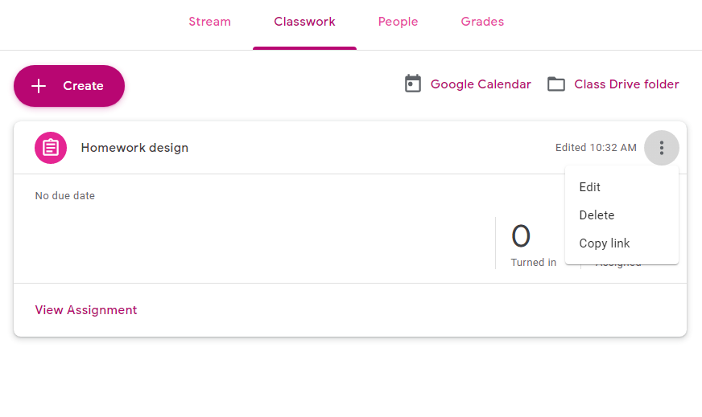

The must clicks Edit for setting everything in the Edit.

* This is location Assignment.

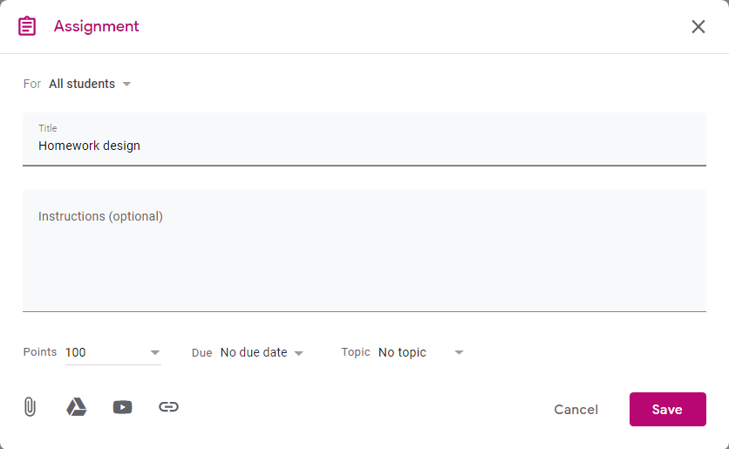

This is specification that teacher the need to uses for students. All students, Title, Instruction and Points, Topic.

* For click on the All student.

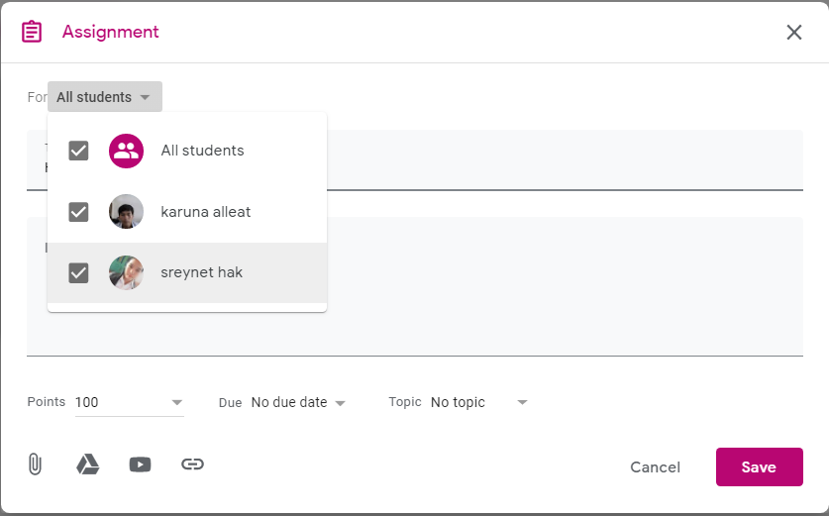

Teacher to click All student for choose all students or one student.

* For Date: Teacher can set the Due date & time for students.

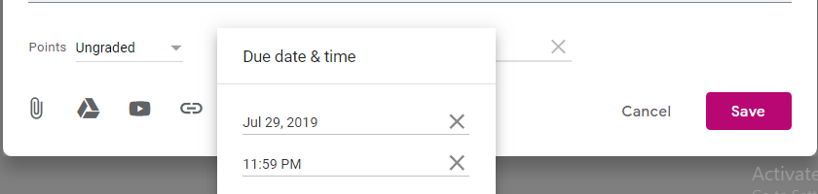

* 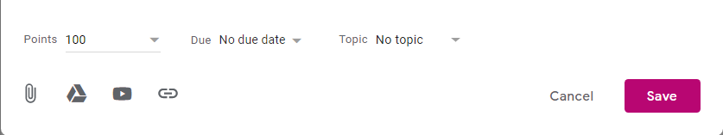For Add file: Teacher can the upload files for students.

The same

* For location insert file using google drive. Teacher can upload files something for students.

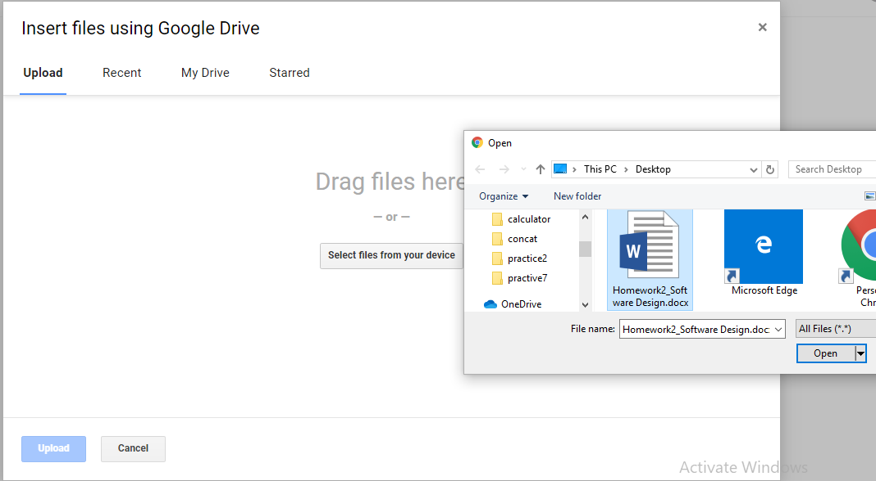

Teacher to click select files after to click files and click open.

* For Youtube: Teacher to click on the Youtube.

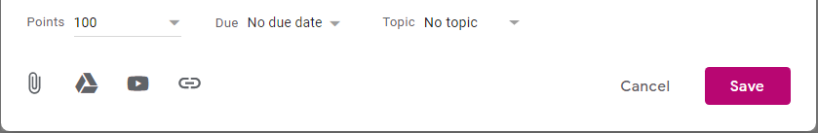

* Output location insert video: Teacher can add the video for students the set video already must to Add or Cancel.

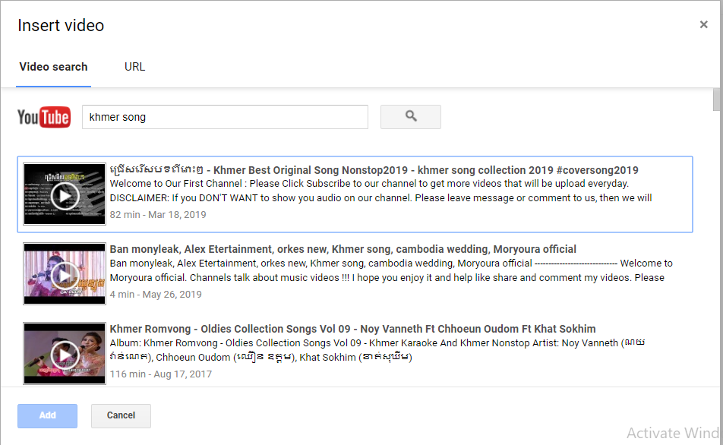

* For link: Teacher click on the link output location Add link.

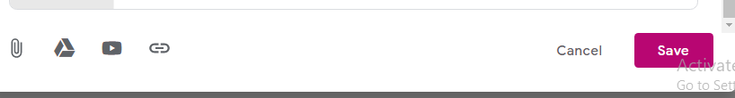

* Location Add link: Teacher can Add link website for students already the must to click Add link or Cancel.

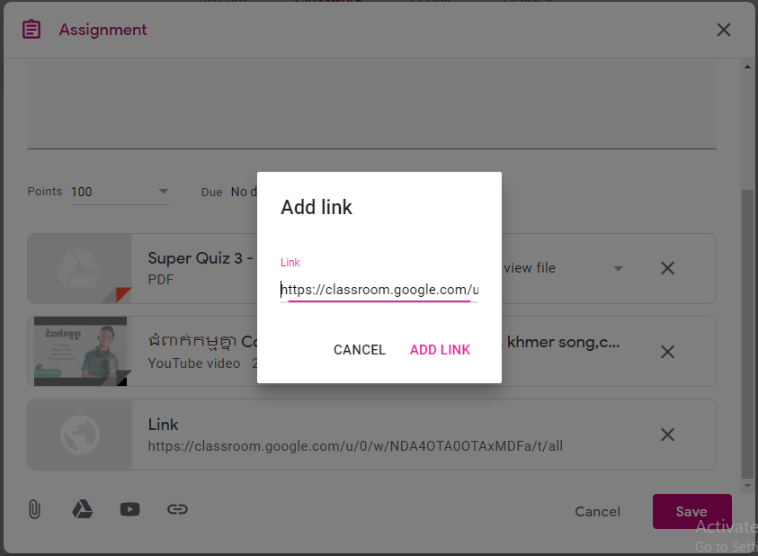

When teacher the setting already this is results that set after

teacher must to click Save or Cancel.

* For specification of requirement
* **Delete:**
* When teacher to click on the Delete. It is output a location delete assignment.
* Teacher can use the delete assignment that teacher put homework for students.
* For Delete: this is location Delete.

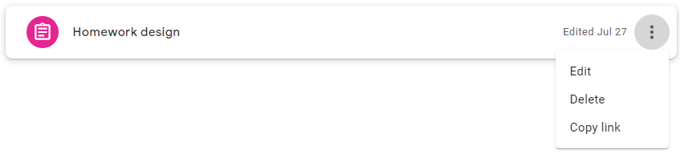

* 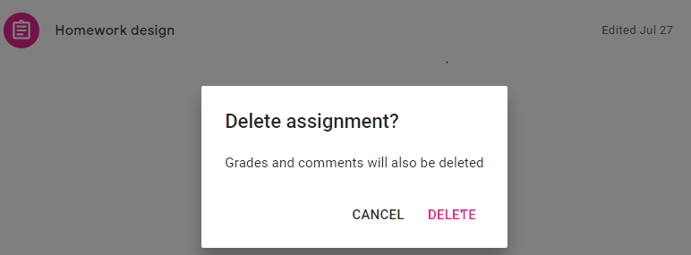This is location Delete assignment. Teacher can use Delete or Cancel.
* For specification of requirement
* **Copy link:**
* Teacher can copy link the keep.

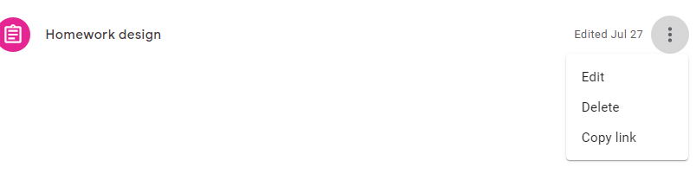

* When teacher click copy link or link website.
* It is output Link copied.

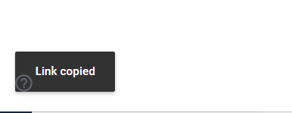

* This is result for copy link.

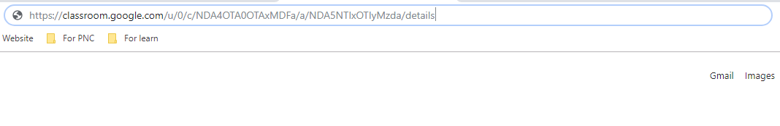

* Classwork feature of the student, there are two requirements.
* For requirement of classwork student.
* View your work
* Google Calendar
* For specification of requirement.
* **View your work:**
* Students can use the View your work and Calendar.
* 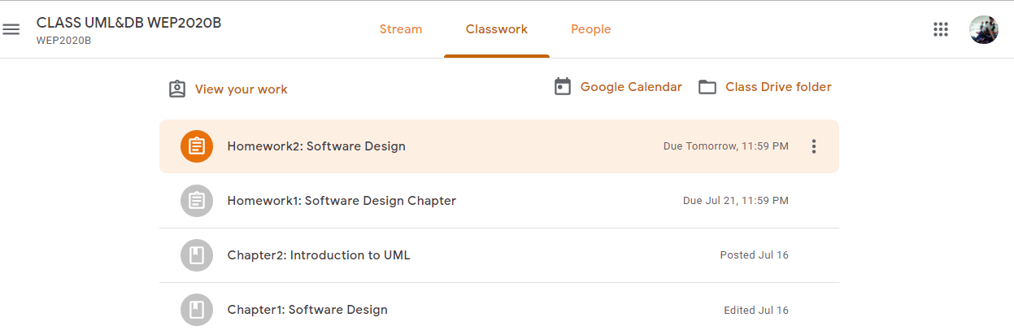For View your work: Student to click View your work output location the profile students.
* This is location the profile student. Students can use see view details and due date & time. When student to click on the view detail output the location homework2: software design.

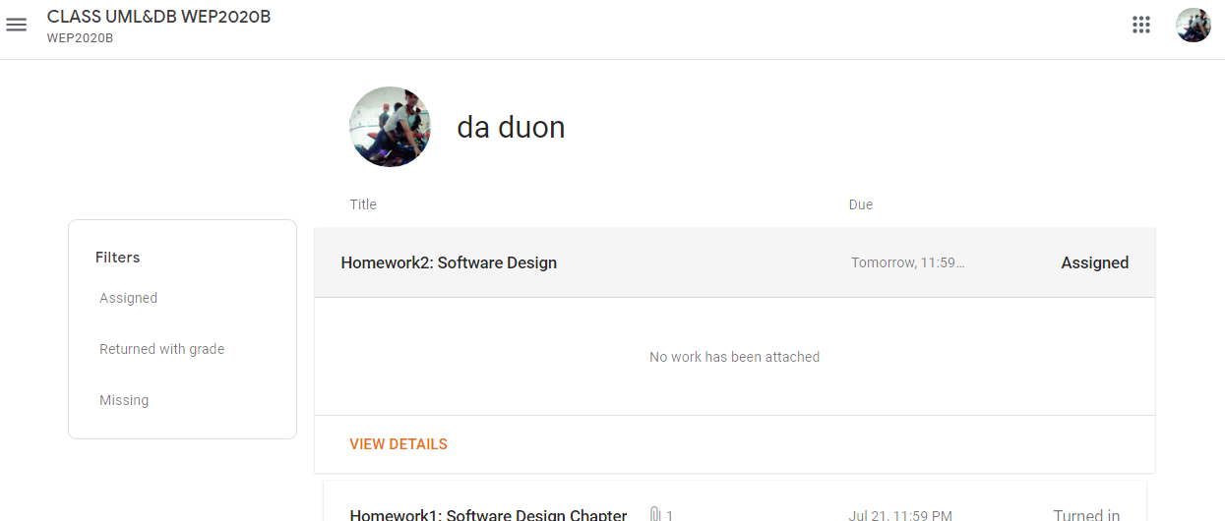

* This is location homework2: software design. Student can use class comments to teacher.
* Student can use Add or Create, viewed and edited by your teacher.
* When student to click on the Add or Create output location add file, link, google drive and Create new.

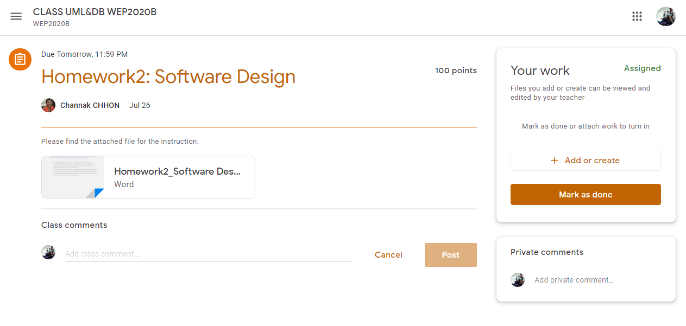

* Student click on the google drive or file output location insert file using google drive.
* 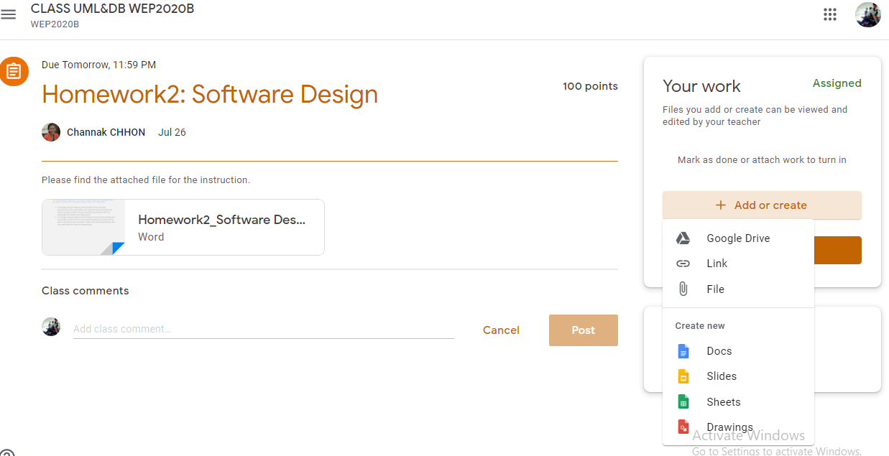Student can down load file from google classroom that put for students.

File teacher for student down load.

Google drive and File the same.

* This is location insert file using google drive: Student can use upload file from head disk and google drive.
* For student must the click select file and click on the file homework and open after to click upload or cancel.
* 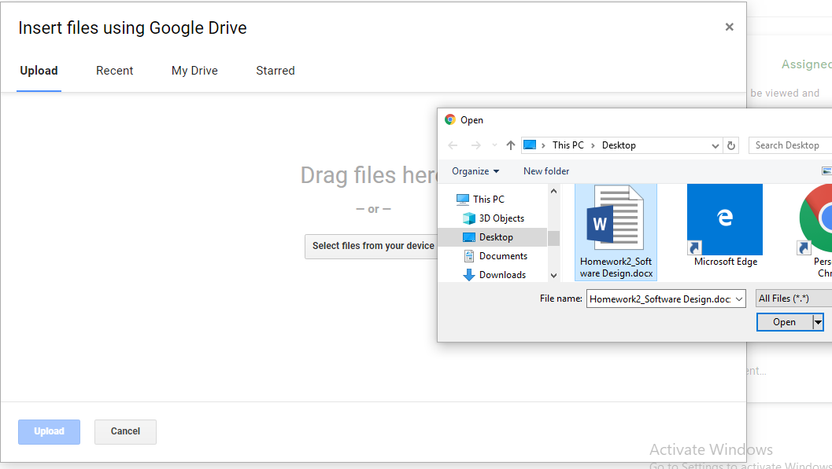For Recent, My Drive and Starred: Student can use upload file from google drive.

Recent, My Drive and Starred the same.

* For Link or Website: Student can use Add link for teacher.
* Student to click Cancel or Add link.

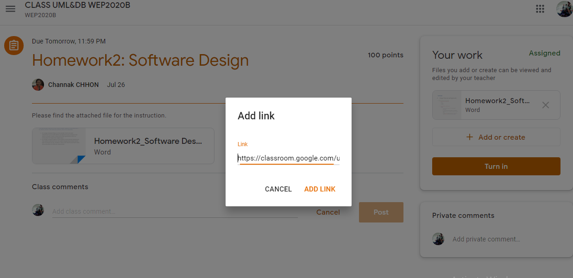

* For create new: Student can use the add Docs, Slides, Sheets and Drawings.

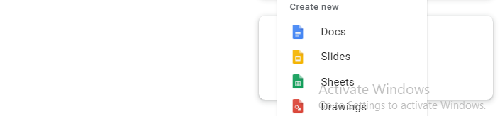

* 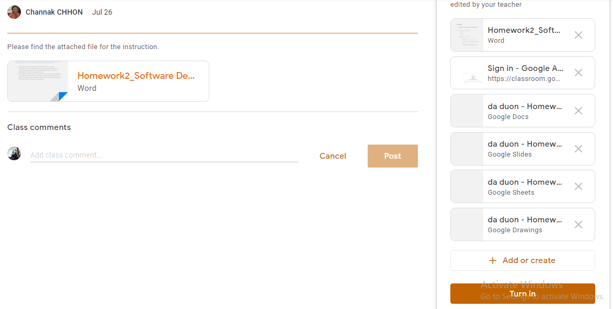This is result student the setting already. After student must to click on the turn in output location Turn in your work.
* 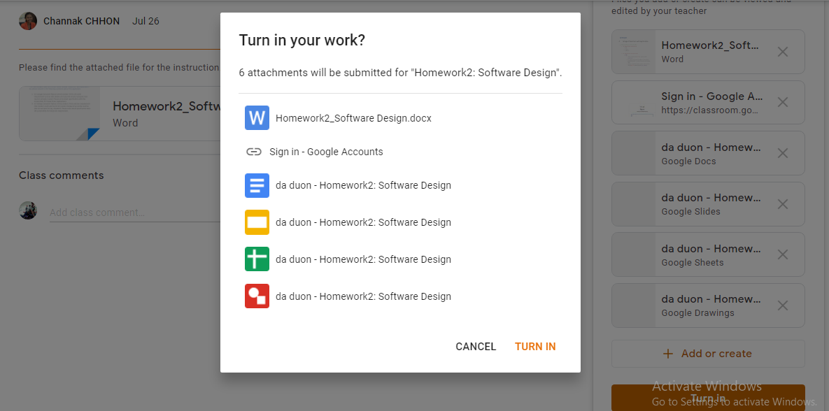This is location turn in your work: Student can the view file again and student must to click Turn in or Cancel for send to teacher.
* For specification of requirement.
* Google Calendar:
* 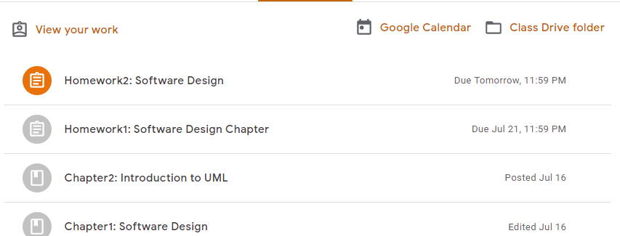Student to click on the google calendar output location Google Calendar.
* For location google calendar: Student can use create, see due date & time, setting, search, help, and see classroom all teacher.

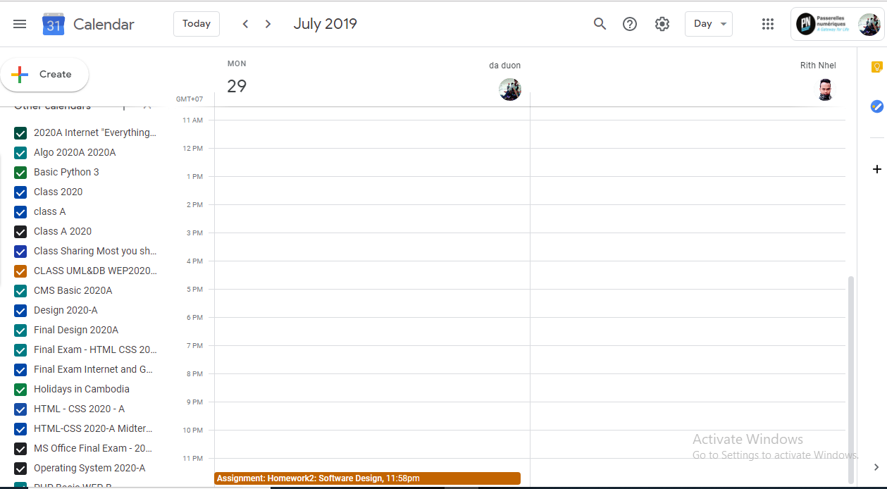

This is search, help, setting and day.

Due date & time

This is classroom all teacher.

* Student click on the create output the location setting of create google calendar.

**This is everything for setting the create google calendar.**

* Student can use for meeting the student or teacher.
* 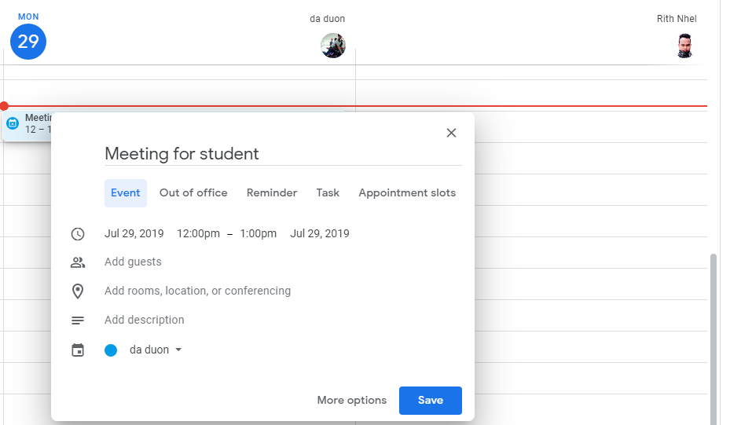There are option Event, Out of office, Reminder, Task, Appointment slots.

This is title

* 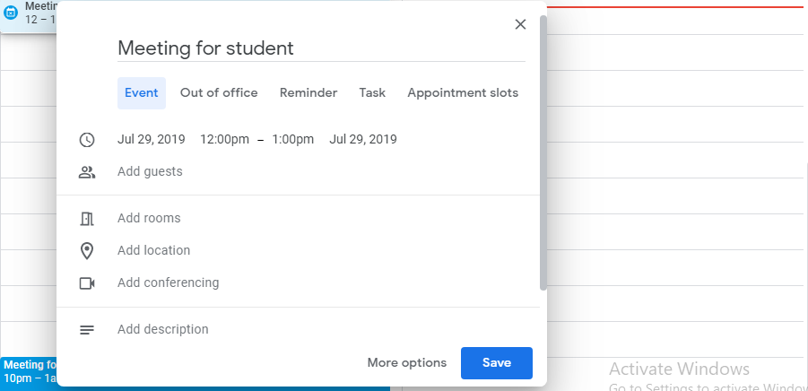For student click Event: Student can the set date & time, add friend or teacher, add rooms and add description.
* For student click on the Out of office: Student can set date & time, Message and Public or Default visibility and Private one more the setting already must click button Save.

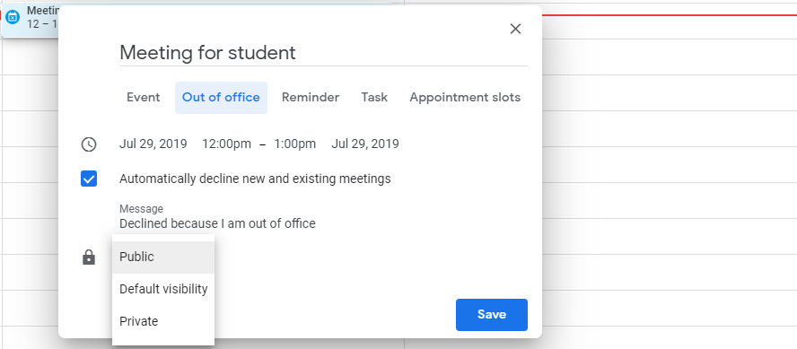

* For student click on the Reminder: Student can the set (Does not repeat, Daily, weekly on Monday, Monthly on the last Monday, annually on July 29, Every weekday) and set all day one more student must to click Save.

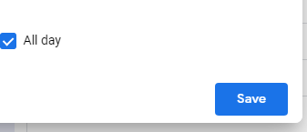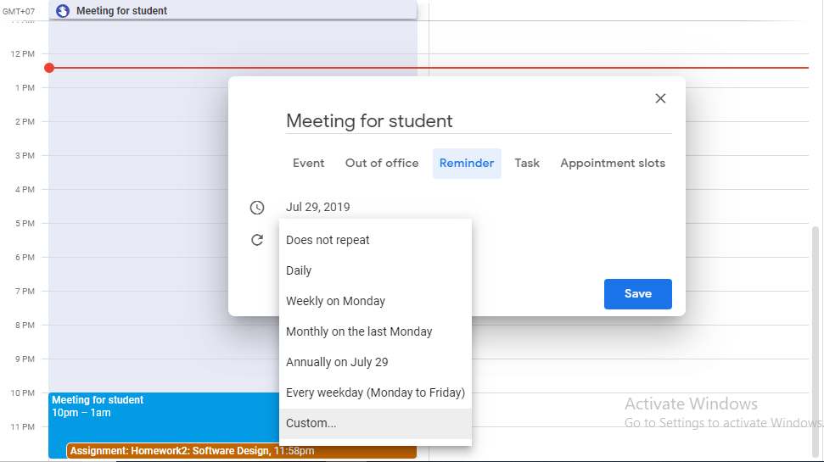

This is for set All day.

Student see color blue.

* For student click on the Task: Student can the add description and all day after must to click Save.

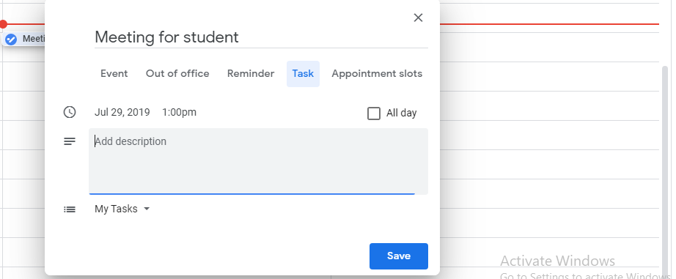

* For student click on the Appointment slots: Student can add minutes and setting Slots with duration, Single slot after student must to click Save or More options.

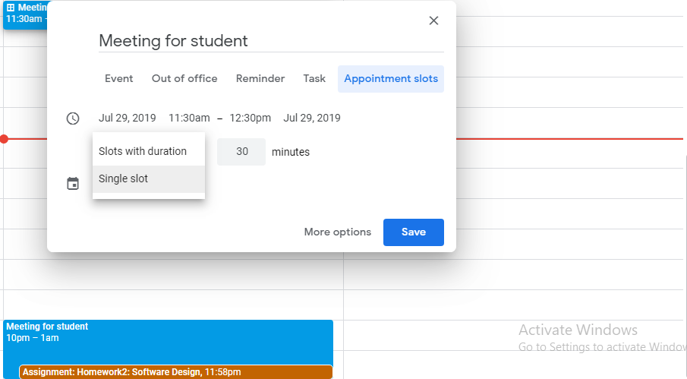

This is result the create.

Th**a**nk

**y**o**u**